

**CSC490**

**Software engineering**

Spring 2020

**Instructor: Karim Youssef**

George Younes  
Youssef Abboud   
Christina Aouad

**Submission 2**

Table of Contents

1.Preface 2

2.Introduction 3

3.Glossary 4

4.Feasibility Study 13

5.User Requirements definition: 14

6. Activity Organization 18

7.Process chart before/after project: 22

8.System Architecture: 24

9. System Requirements Specifications: 28

10.System models: 31

11.System evolution: 48

12.Appendices: 49

13. Risk management: 51

14.Resource List: 51

15.Scheduling management: 52

16.Index: 53

# 1.Preface

This submission is based on the modified version of the IEEE/ANSI 830-98 requirement specification document. This document would include:

1.Preface

2.Introduction

3.Glossary

4.User requirements definition

5.System architecture

6.System requirements specification

7.System models

8.System evolution

9.Appendices

10.Index

# 2.Introduction

Pharmacy Rahbani, located in Jbeil, is one of the biggest and largest pharmacies in Lebanon especially in Jbeil. The pharmacy includes 37 employees; it consists of 3 main departments: Stock, Accounting and the actual pharmacy. The main reason behind this pharmacy’s popularity is its ability to import certain medication from abroad.

* Clients have been increasing exponentially. Actual visits to the pharmacy are well handled, a client would enter the pharmacy and ask for a particular medication and the staff will give said client their needs. Many clients, however, call the pharmacy to make sure what they need is actually available or to simply ask a question. The issue around this is that the pharmacy, having one phone and one employee responsible for this, is not being able to handle all the phone calls effectively. This results in angry clients and many complaints such as unanswered phone calls or missing medication.

A solution:

Having a website that shows all available products along with the price, the quantity left, and expiry date. The client can email the pharmacy from the website regarding any question. Some products can even be purchased online (following the Lebanese law).

The Website would be always available an accessible by everyone. The system main function is to provide clients with some of the available products in addition to being a communication platform with the pharmacy.

* Another problem the pharmacy faces is the program used for the stock is slow; it is old and does not meet the specified requirements.

A solution:

Designing an updated program for the stock (suppliers, invoices, accounting, inventory, expiry date list, price list……).

This program would be used alongside with the accounting’s system, the system main function is to receive invoices and store them in the database. Every month the accounting department would make sure that all invoices are received and that the amount received is equal to the amount paid.

The pharmacy is losing clients due to the problems it is facing. Our software programs will try and solve all issues faced by the business in hopes of reducing its losses. By handling all clients efficiently and professionally, the business will be able to grow much faster, increasing its profits.

# 3.Glossary

**A**

**Absorption Rate** - The amount of time it takes after a drug is administered for it to enter the bloodstream.

**Acute** - Usually refers to a condition that has a fast onset time, severe effect, and short course of duration.

**Admixture** - Two or more drugs blended or mixed together to create a desired substance or solution.

**Adverse Reaction** - When the body has an undesired or negative response to a medication or drug-drug interaction.

**Agonist** - A drug that triggers a receptor to produce a physiologic response. An easy way to remember the difference is: Agonists try to make things happen; Antagonists try to stop things from happening.

**Allegation** - An unofficial Math maneuver that can be used to determine ratios for compounding.

**Allergic Reaction** - A response from the immune system to a substance which a patient has an allergy to.

**Allergy** - When the body is highly sensitive to (an otherwise harmless) substance.

**Amphetamine** - Central nervous system stimulant prescribed for the treatment of ADHD, Narcolepsy, Obesity and other conditions. Also known as "Speed", Amphetamines are highly addictive, and DEA controlled.

**Ampule** - A (small) sealed glass vial that is to be 'broken' open and normally contains injection solution.

**Analgesic** - Often referred to as "pain relievers", Analgesics are drug used to reduce or suppress pain. (ex. Aspirin, Ibuprofen, Oxycodone, etc.)

**Anaphylactic Shock** - The body's reaction to Anaphylaxis caused by your immune system.

**Anaphylaxis** - An extreme reaction to something you're severely allergic to, such as peanuts, shellfish or a bee sting which requires emergency medical attention and may be life threatening.

**Anesthetic** - Drugs that create an insensitivity to pain by blocking nerve transmission to the brain.

**Antagonist** - Drugs designed to block a receptor-mediated effect created by neurotransmitters. An easy way to remember the difference is: Agonists try to make things happen; Antagonists try to stop things from happening.

**Anticoagulant** - A drug that is used to decrease or prevent the formation of blood clots

**Anticonvulsant** - These are drugs used to help prevent seizures or to lessen the severity of a seizure.

**Antiemetic** - Drugs used to prevent, alleviate or suppress nausea and vomiting.

**Antihistamine** -Drugs used to counteract the immune systems histamine reaction to allergy or respiratory illness.

**Antineoplastic** - Drugs prescribed to slow the growth of malignant tumors.

**Antipyretic** - Drugs used to prevent or reduce fever (abnormally high body temperature).

**Antispasmodic** - Drugs used to relieve or prevent muscle spasms.

**Antitussive** - Drugs used to suppress or relieve coughing.

**Apothecary** - Another word for pharmacist. However, it also refers to a system of weights and measures.

**Aqueous** -Refers to when something is, or to be water based.

**Aseptic** **Technique**- A sanitation practice performed with a goal of minimizing contamination by pathogens.

**Auxiliary Label** - Additional labels placed on prescription packaging that provide supplementary information, various warnings, routes of administrations, etc.

**AWP (Average Wholesale Price)** - Found in the Redbook, the AWP of a drug is the average price at which drugs are purchased at the wholesale level. It is mainly used to determine third-party reimbursement.

**B**

**Bactericidal** - Drugs that destroy / kill bacteria.

**Bacteriostatic** - Drugs that slow down or inhibit the duplication (growth) of bacteria.

**Bio-Availability** - The rate which a drug is made available to the target site of physiological activity

**Bio-Equivalence** - When a drug has the same biological effect / efficacy / bioavailability as a a similar drug with a different formulation.

**Bronchodilator** - A drug that widens passages in the lungs to ease breathing.

**Buccal** - Tablet held between the cheek and gum which dissolves, thereby permitting quicker absorption

**C**

**CC**- Abbreviation for cubic centimeter = 1 mL (Milliliter)

**Celsius** - It's basically the same as Centigrade. (see next term below)

**Centigrade** - Standard measure of temperature in Science / Metric system. Water freezes at 0 and boils at 100.

**Closed Formular**y - A program where drugs not listed in the Formulary require prior authorization or may not be covered whatsoever by the insurer.

**Coinsurance** - A cost-sharing method where a patient pays only a percentage for medication after their deductible is met, and their insurer pays the rest.

**Chronic** -Refers to an illness that persists for a long period of time or frequent re-occurrence.

**Communicable** -Refers to illness / disease that is contagious or transmittable to others.

**Compound** - A final substance (or solution) made from two or more substances.

**Compounding** - The creation of a particular drug mixture to fit the unique need of a patient.

**Controlled Release (CR)** -Refers to drugs formulations designed to release gradually over a specific time.

**Controlled Substance** - In the U.S., it refers to drugs that are regulated by the Drug Enforcement Agency.

**Co-Pay** - A set dollar amount a patient must pay for a prescription out-of-pocket when it's dispensed.

**D**

**Deductible -**A set amount a patient must pay before an insurance provider will begin paying claims.

**Dehydration** - When the body loses water and electrolytes essential for bodily function.

**Denominator** - Number below the line in a fraction that indicates the number which one whole is divided.

**Diluent** - A liquid that decreases the concentration of a solution by diluting it or turns powder into a liquid.

**Diuretic** - Drugs that increase the body's urine discharge flow, thereby decreasing overall fluid accumulation.

**Displacement** - When fluid volume appears greater because a non-fluid substance is placed into it.

**Dopamine** - A neurotransmitter essential to the normal functioning of the central nervous system

**Dram** **(Fluid)** - is equal to 1/8 of an oz. So, 8 Drams = 1oz.  And, 1 Fluid Dram is roughly equal to 3.7mL.

**Drop Factor** - In IV administration, drop factor usually refers to how many drops make up 1 mL. (gtts/mL)

**E**

**Effervescent Tablet** - These emit bubbles when put into water, and rapidly dissolve usually leaving a froth

**Electrolytes** - Are fluids containing sodium and potassium salts designed to maintain or replenish proper balance of a patient's electrolyte levels. They are commonly used after dehydration of along with diuretics.

**Elimination** - Another word for Excretion, which is when the body removes non-usable waste. In pharmacokinetics, this is the last step.

**Elixir** - A sweetened, hydro-alcoholic solution that is taken orally and contains one or more active drugs.

**Emulsion** -A mixture of two or more liquids that are normally immiscible with each other.

**Enema** - As a dosage form: An injection of fluid into the rectum containing suspended drug particles.

**Enteric Coated** - An additional coating on a tablet to control where in the digestive system a drug will dissolve and be absorbed.

**Expectorant** - Drugs that work in the respiratory system to clear out mucus and phlegm.

**Extemporaneous Compounding** - Following a set / written recipe to compound prescription drugs.

**F**

**Fahrenheit** - Standard temperature measurement scale in the U.S. - Water freezes at 32 and boils at 220.

**Flow Rate** - In IV math, it's the amount of drops that are needed per minute. (gtt/min)

**Formulary** - A predetermined list of drugs that are considered preferred and acceptable by a therapeutic committee for managed care systems. A formulary is carefully chosen in order to offer a wide enough range to accommodate medical therapies, but not wasteful.

**G**

**Gastrointestinal** - Anything relating to the stomach and large intestines.

**Generic Drug** - A medication not protected by patent, distributed and marketed under its pharmaceutical / chemical name, usually by multiple manufacturers at a lower end-user cost.

**Grain** - Unit of dry measure. There are 437.5 Grains / Ounce and 15.43 grains per gram.

**Gram** - Unit of dry measure. 15.43 grains make up 1 gram. A gram is also 1/1000 of a Kg.

**H**

**Half-Life** - The amount of time it takes for half of the drug to be eliminated from the body.

**Health Maintenance Organization (HMO)** - A health insurance plan where patients are assigned a primary care physician, who must be initially consulted for everything and then personally refer them to specialists within the organization's network.

**HEPA** - Acronym for: **H**igh **E**fficiency **P**articulate **A**ir. It is a type of highly effective air filter.

**Hypnotic** **Drug**- These slow the central nervous system to reduce anxiety and induce sleep

**I**

**Inert ingredients -**Filler / non-drug ingredients in medication which are inactive.

**Infusion rate** - Fluid volume of an IV necessary to deliver enough drug within the timeframe the prescriber sets.

**Intracardiac** -Refers to an injection administered directly into the patient’s heart.

**Intradermal** -An injection into the top layer of skin, done at an angle.

**Inventory** - A comprehensive list of the assets / items currently and physically in stock.

**Isotonic** - Refers to a solution with the same tonicity (Saline) as human blood.

**K**

**Kilo** - In the metric system it means *1000. Most often used as slang to mean Kilogram (1000 Grams)

**L**

**Laxative** - A Substance that promotes bowel movement, normally prescribed for mild constipation.

**Legend Drug** - Means the same as prescription drug; Must have a valid prescription to be dispensed.

**Liter** - Fluid measurement in the metric system. 1 Liter = 1000 mL - and - 1 Liter = 33.81 Ounces

**Lozenge** - Known better as a cough drop; picked up the name Lozenge because of its (sometimes) diamond shape. It's designed to dissolve in the mouth to sooth and lubricate the throat.

**M**

**Markup Percentage** - Usually refers to the price a retailer charges above their wholesale cost as a profit.

**Meniscus** - The curved surface on the top of fluid in a glass container.

**Micro** - In the metric system it means 1/million. (ex.: Microgram = 1/1,000,000 of a Gram)

**Milli** - In the metric system it means 1/1000. (ex.: Milliliter = 1/1000 of a Liter)

**Misbranded** - When a product is labeled or marketed falsely or in a misleading manner.

**MOA** - (Mechanism of Action) The method in which a drug produces an effect on the condition it's intended to treat.

**N**

**Narcotics** - Drugs that induce various stages of narcosis to dull the senses, typically used to treat pain.

**Net Profit** - A measure of profitability after all business-related expenses have been accounted for.

**NS** - (normal Saline) Isotonic solution of 0.9% concentration of sodium chloride in sterile water.

**Numerator** - The top number in a math fraction, which will be divided by the denominator (bottom number).

**O**

**Ointment** - A preparation of medication disbursed in a thick fluid, typically used to treat skin disorders.

**Ophthalmic** -Refers to the eye. For treatment of, around or in the patient's eye.

**Opiate** - Drugs that are derived from opium, typically used for pain management.

**Opioid** - Synthetic drugs that have the narcotic effects of opium, typically used for pain management.

**Orange Book** - Published by the FDA, the "Approved Drug Products with Therapeutic Equivalence Evaluations" is available as a resource to help healthcare professionals in choosing drugs for generic substitution.

**OTC Drugs** - Medications sold "**O**ver **T**he **C**ounter", which can be obtained without prescription.

**Otic** - Refers to the ear. For treatment of, around or in the patient's ear.

**P**

**Parenteral** -Refers to drug administration that is delivered directly, and not through the intestinal tract. Mainly used to classify injection routes of administration.

**Pharmacokinetics** - What the body does with a drug from when it's administered to the time it's eliminated.

**Pharmacology** - A vague term which refers to the science and study of drugs, including the chemistry and biological effects.

**pH Level** - A measure of the alkalinity or acidity of a solution. The pH scale ranges from 0-14 and 7 is neutral.

**Pint** - Fluid measurement 1 Pint = 16 Ounces

**Placebo** - Commonly referred to as a 'sugar pill'. A placebo contains no medicine. However, the patient supposes it does, and results may occur because of this belief. Placebos are mostly used in clinical trials to experiment with groups of people in double-blind studies.

**Preferred Provider Organization (PPO)** - A health insurance plan that allows members to seek care directly from network providers without a referral.

**Psychotropic** - Refers to drugs that have a psychological effect and result in altering a patient's mind, mood or behavior.

**Q**

**Quart** - Fluid measurement which really just means a quarter of a gallon.  1 Quart = 1/4 Gallon

**R**

**Ratio** - Math term used to show the relative difference between two quantities.  
  
**Reconstitute** - Refers to when drugs in powder form need to be mixed with a fluid before they are administered.  
  
**Red Book** - Pharmaceutical reference tool used to determine Average Wholesale Price (AWP), suggested retail price and other standardized drug pricing data mainly for 3rd party insurance billing purposes.  
  
**Route of Administration** - The prescribed path a drug is to be taken into the body.  
  
**Rx** - An internationally recognized symbol or abbreviation for "Prescription".

**S**

**Scored Tablet -**Drug tablets which are indented during manufacturing, to make easier to break into half or quarters.

**Sedative** - Refers to drugs that work on the central nervous system to help calm anxiety, stress, etc..  
  
**Sig Code** - Medical abbreviations and acronyms used in healthcare to communicate directions.  
  
**Solute** - Solute is a substance dissolved into a solvent to make a solution mixture. Usually, solute refers to the active ingredient(s) in a solution.

**Solution** - A liquid mixture in which the minor component (the **solute**) is uniformly distributed within the major component (the **solvent**).  
  
**Solvent** - A solvent is (usually) a liquid that has the ability to dissolve another substance. The most common and available solvent is water.

**Subcutaneous** - Refers to an IV injection placed into the skin's subcutaneous layer (3rd down).  
  
**Sublingual** - (Under your tongue) Refers to placing a tablet under your tongue to dissolve.  
  
**Suppository** - A drug dosage form that is to be inserted into a body cavity, where it will dissolve and be absorbed.  
  
**Suspension** - A liquid solution containing tiny undissolved drug particles 'suspended' in it.  
  
**Symptom** - Refers to a sign or characteristic that may serve as a clue to determine an illness or disease.

**Syrup** - A liquid preparation typically containing a high concentration of a sugar (or sugar substitute), a flavoring agent, and active drug ingredients.

**T**

**Tincture** - Refers to a drug dissolved in an alcohol solution to make an oral preparation.  
  
**TPN Solution** - Total Parenteral Nutrition provides nourishment to patients intravenously when their digestive tract needs to be bypassed.  
  
**Transdermal** - When a drug is administered through the skin, usually with a patch or ointment.  
  
**Trituration** - When a solid substance is ground into fine particles for compounding purposes.

**V**

**Vaporizer** - A medical device used for converting a medicated liquid into vapor for inhalation.

**Vasodilator** - Refers to drugs that widen blood vessels, allowing for blood to flow more freely through arteries. And, that lowers blood pressure and allows your heart to not work so hard.  
  
**Vial** - A small glass or plastic container with a closure used to contain and store chemicals.

# 4.Feasibility Study

After meeting with the client, the team members sat down and discussed the project. It was concluded that the project is very much feasible.

Most resources, as shown below, are free and available. All paid software and hardware amount to a fair sum as seen below as well.

The risk analysis shows what to expect and how to avoid or minimize effects of problems.

The team’s skills as well as their collaborative and teamworking qualities are able to pull this project off (a stock management software and a website).

# 5.User Requirements definition:

5.1 Stock management system:

**How does the system work?**

Human input is what drives this program. Clients would receive an invoice with the ordered items. His/ Her responsibility is to check if the received quantities and expiry dates are the same mentioned in the invoice. Once this is done the next step is to enter the invoice and save it in the database. Every month, the suppliers would come to the pharmacy to collect payments. At this stage, the accounting department would make sure that the amount of the invoices in the pharmacy database matches the amount presented by the suppliers. If they match, payments are made, if not the suppliers and the accounting must find what’s wrong.

**Steps:**

Once the stock worker makes sure that quantities are received, the invoice should be added to the database following numerous steps:

1. Enter the invoice number

2. Choose whether the invoice is the US or LBP.

3. Choose the Suppliers from the suppliers list.

4. Insert the Received and the Due Date (usually one month far from the received date)

5.If the item you wish to add have a barcode, write the barcode and press enter.

If the item does not have a barcode, write the first name of the item.

If the item does not exist in the pharmacy, press on the button stock the new then

Create the new items (it is mandatory to choose a name, brand, suppliers, category

and department).

6.Choose the quantity received

7.Choose the expiry date.

9.You will find a button after the date named “offer” click on it just in case the chosen Item is for free.

10.Copy the price from the invoice to the box named “bill price”.

11.Choose the discount rate (for Lebanese medication = 22.5%)

12.Choose the TVA (normally = 11%)

13.Verify the TTC price

14.Verify that the Total amount in the box named TOTAL TTC is equal to the total

amount of the invoice received.

15.If the two amounts are equal press save to save the invoice in the database.

**Additional options:**

Buttons meanings:

-NEW: Starting a new invoice.

-SAVE: Save the invoice.

-MODIFY: Modify an invoice (ATTENTION: You CAN NOT modify an invoice if it is Paid).

-DELETE: Delete an invoice (Be careful).

-BARCODE: Printing barcode for items without barcode.

-PRINT: Printing the invoice.

-CLOSE: Exit the system.

**Additional information:**

Once the invoice is printed it should be attached to the invoice given by the suppliers and every day the invoices should be filed in the accounting department according to the supplier names.

**Suggestions:**

The person that enters the invoice should sign his/her name on the invoice. This would be efficient to make sure that the invoice was received.

**Functional requirements:**

-Adding invoices to the system.

-Adding received items to the pharmacy’s database.

-Keeping control on the sold and purchased items for later orders.

-Keeping track of which supplier supply which item.

-Creating new non-existing items.

-Keeping track of the numbers of invoices which will eventually lead to easier way to find out if the amount that should be paid is true.

Example: Invoice number 125984 should be paid

Accounting department would simply search for the number 125984 and

Check if the amount entered on the system is equal to the supplier’s amount.

**Non-Functional requirements:**

-Capacity: The database could contain up to 2 power 100 items.

-Recoverability: A backup database exist for every department.

-Data integrity: Each medication is added to the system under the proper department (medication, food supplements, para-medicals, cosmetics, baby food, baby toiletry….)

-Availability: If the user has a username and a password the program is available 24/7.

-Scalability: No matter how the size of the data the program can manage it.

-Reliability: The program is reliable and efficient it makes the work easier and save

every single invoice.

-Maintainability: The sub-functions of the program are written in a way that the

dependencies are minimized. This makes maintainability easier

to handle.

5.2 Pharmacy Website:

**How does the system work?**

Human input and interaction are of great importance. A person would want to check for item availability. His/ Her role is to enter the given website where all the information about the Pharmacy are presented. Once said individual is on the Website, he/she selects what he or she needs: Shop Tab to check if certain item is available, Contact Us Tab to Contact the Pharmacy or About tab that will give him/her all the essential information about the Pharmacy.

Admins are given a special login access to check what item is being and the access rate of the website.

**Steps of the system:**

Once the Customer enters the website, they are given different tabs of interaction to choose from:

1. Proceed to the Website.

2. Interact with the home page.

3. Choose which tab to proceed to.

4. Choose Shop to check whether an item is available or not.

5. Choose Contact Us for any inquiry to contact the pharmacy a soon as possible.

6.Choose About Us to get any information about the Pharmacy, the about tab contains all essentials information needed about the pharmacy.

7.If his item is available in the Shop Tab the User afterwards may then go to the pharmacy to buy the product selected as because pharmaceutical online selling in Lebanon is Forbidden.

**Additional options:**

Buttons meanings:

-LOGIN icon: located on the homepage on the right top corner, its an easy way for Admins to login for the privileged users.

-the admin enters the email and password given

-once logged in he will be redirected to a CRUD page

-on the CRUD page the admin will be able to all sorts of functions.

**Additional information:**

Once the price has changed the admin can change a price of an item or even the price database

**Suggestions:**

The person that enters the admin form should know the sign in invoices a lot of attempt of signing in will eventually close the window.

**Functional requirements:**

* Adding items to the pharmacy’s database.
* removing items from the pharmacy’s database.
* Keeping an eye on which item is being viewed the most.
* Change and update item price in database.

**Non-Functional requirements:**

* Capacity: The database could contain up to 2 power 100 items.
* Recoverability: A backup database exist as for a backup code exist for the website itself.
* Data integrity: Each medication is added to the system under the proper department (medication, food supplements, para-medicals, cosmetics, baby food, baby toiletry….)
* Availability: see availability of items 24/7.
* Availability(admins): if you have a username and password functions will be available 24/7 for the admin
* Scalability: No matter how the size of the data the program can manage it.
* Reliability: The program is reliable and efficient it makes the work easier.
* Maintainability: The website sub-codes are written in a way that most of the part are dependent to each one another this makes maintainability easier.

# 6. Activity Organization

6.1 Activity Network

6.2 Table of activities

|  |  |  |
| --- | --- | --- |
| **Activity** | **Duration (Days)** | **Dependencies** |
| T1: Talk with Client | 7 | N/A |
| T2: Feasibility study | 14 | T1 |
| T3: Start Database | 14 | N/A |
| T4: Requirements | 5 | T2 (M1) |
| T5: Activity organization | 2 | T4 |
| T6: Front-end | 9 | T3 |
| T7: Creating Frame | 7 | N/A |
| T8: Finalize Database | 4 | T6 |
| T9: Creating methods | 14 | T7 |
| T10: Back-end | 21 | T10 |
| T11: Linking Methods to Frame | 7 | T9 |

6.3 Activity Bar chart

6.4 Staff Allocation

# 7.Process chart before/after project:

Invoice#

Invoices list

Accounting

Brands

Barcode

Suppliers

# 8.System Architecture:

8.1 Stock System:

  

**User User Interface Pharmacy Database**

SAVE

INFO

Information saved

Choose suppliers name

Choose USD or LBP

Enter Invoice Number

**NEW INVOICE**

**ENTERING EXISTING ITEM**

**I**

**TEM**

Enter prices 

INFO

MODIFY

Enter expiry date

Enter quantity

Write barcode, Press ENTER

Invalid Item, Create New Item

Valid Item, CONTIUNE 

IF IT IS A NEW ITEM SEND INVALID

IF ITEM EXIST SEND VALID TO USER

**CREATING NEW ITEM**

**I**

**TEM**

Sign printed invoice****

Print the invoice

Go to: Stock, New, Add

Add: Name, Brand, Department



Invoice SAVED

IF {no more items} Press SAVE



SAVE

INVOICE

8.2 Pharmacy Website:



**User User Interface Pharmacy Database**

**Show available and not available items**

Access the About Page

Retrieve all the data

Access the Contact Page

Access Database

Access the Shop Page

Access the Website

**6.**





**Admin User Interface Pharmacy Database**

Change item price

Access the About Page

SAVE &Apply

Access the Contact Page

Add item

Access the Shop Page

Remove item

Access Database

Access the CRUD Page

Sign In

using admin logins

**6.**

# 9. System Requirements Specifications:

9.1 Stock System:

A. Functional requirements:

**Store the necessary information of the drugs:** The pharmacy system stores the detailed information about each medicine including actual name, formula of medicine, quantities, suppliers, brands, categories and expiry dates.

**Searching Medicine and other Data’s:** The pharmacy system allows one to easily search for medicine, showing which suppliers supply it and any further information about said supplier (location, telephone number, time availability). The searching process is based on the name of the medicine and it is identified based on that name in the stock database. In addition, when the user searches for an item on the search bar, the related information are displayed in the screen and one can select the actual item that is needed (In case several medications have the same name).

**Modifying Pharmacy Data in the system:** Replacing expired medicines with new ones, updating incorrect data (ex: supplier changed), deleting old data…   
All this can be done on the system.

**Support multi languages:** The system is supposed to work primarily in ENGLISH (It can be modified to FRENCH or ARABIC). The user can use one of these languages. If the user is unfamiliar with a certain language, he/she can switch to another language.

**In brief, the functional requirements of the system:**

* Store Medicine data.
* Search Medicine and data effectively.
* Update, delete and edit medicine information.
* Generate reports.
* Store bills and invoices.

B. Non-Functional requirements:

**ϖ Usability:** Anyone familiar in using windows operation can operate the system since it is user friendly. An instruction menu is available on how to use the system (clear without any ambiguity).

**ϖ Reliability:** The pharmacy system is available based on the user needs, can work properly, and do transactions efficiently including safe data management of the pharmacy. For invalid and malfunctioned operations, the system will restart within 5 seconds in order to prevent data loss and ensure safe operation. Modifications are only allowed after entering a correct password. The pharmacy’s manager is in control of the system. As a result, data is protected and controlled by only the administrator.

**ϖ Performance:** The pharmacy management system responds quickly, about two seconds or less, and can be accessed by one or more users at a time. To access, the user must first login using credentials given by the admin. The system can store data up to 150 GB of data. If the system is busy or malfunctions, it may wait up to 1 minute and then asks the user to wait or restart.

**ϖ User interface:** The user interface is friendly and is easy to use. Also, for the purpose of simplicity, the database can be connected to excel to easily check expiry dates, sales…

**ϖ Operation:** The pharmacy management system is operated and controlled by the pharmacy manager for safe work.

**ϖ Supportability:** This pharmacy management system operates in any version of windows operating system (windows xp, windows 2003, windows 7, windows 8, 9 10 and other related versions). The system can be easily maintained by the manager of the pharmacy system by using the prepared documents of the system for easy maintenance. It is also maintained by the system developers for corrective and other heavy problems.

**ϖ Implementation:** The system is implemented in Intel(R) Core (TM) i3 processor with 2 GB RAM,32-bit computer. And it is implemented through testing on both Black and White testing. (Coding platforms: Visual studio and Xampp).

* 1. Pharmacy website:

A. Functional requirements:

**Searching for a Medicine and see its availability**: The Website data stores information on whether certain medicines are available or not. This makes it easier for clients and might prevent them a useless drive.

**Store the necessary information about the pharmacy:** The website also shows all necessary information about the pharmacy: location, staff, owner, opening times…

**Modifying Pharmacy Medicine shown on the website:** Admins can modify the shown medicines on the website; either by deleting, adding or updating.

**In brief, the functional requirements of the system:**

* Store Medicine data.
* Search Medicine and present them in an easy and professional way.
* Update, delete and edit shown medicine information.

# 10.System models:

10.1 Stock System:

The pharmacy management system is based on different model view to represent the system in understandable way such as in scenarios, use case models, object models, Activity diagrams, and sequence diagrams.

##### Scenarios

The pharmacy management system registers medicine, store on the database again accessed when needed, remove when obsolete, modified when additional information is required. Several scenarios exist, we will present every possible scenario with the steps that must be followed to deal with it. After mentioning the flow of event of every scenario we will mention some alternative sequence which will help the user to deal with every possible problem while working on the system.

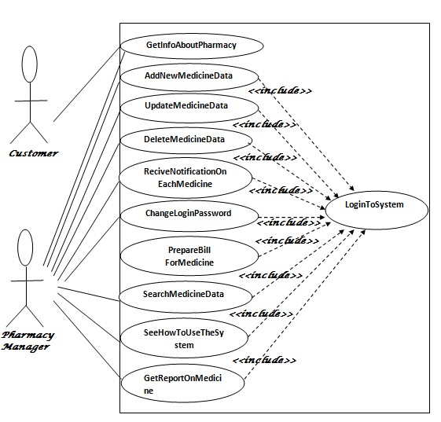

**Adding an Item**

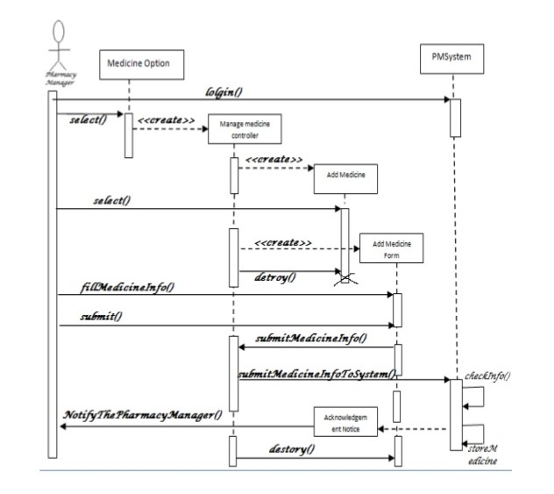

**Deleting an item**

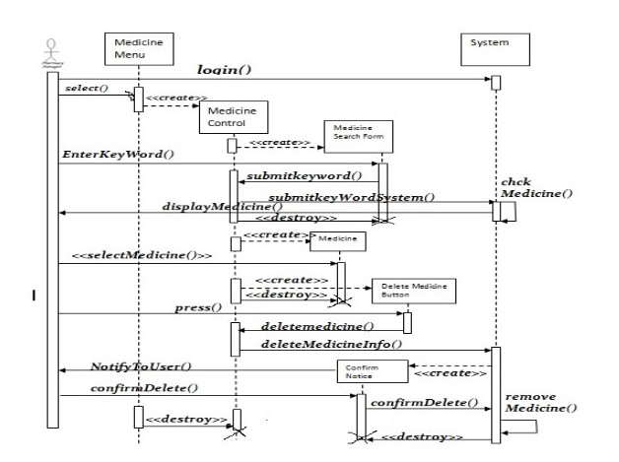

**Searching for a medicine**

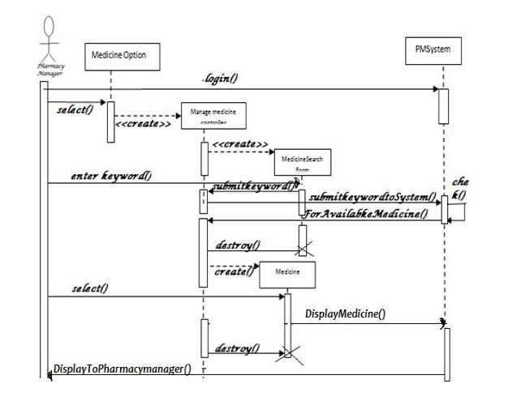

**Login Form**

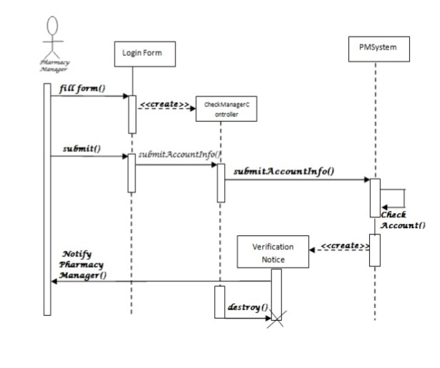

**Pharmacy Management system**

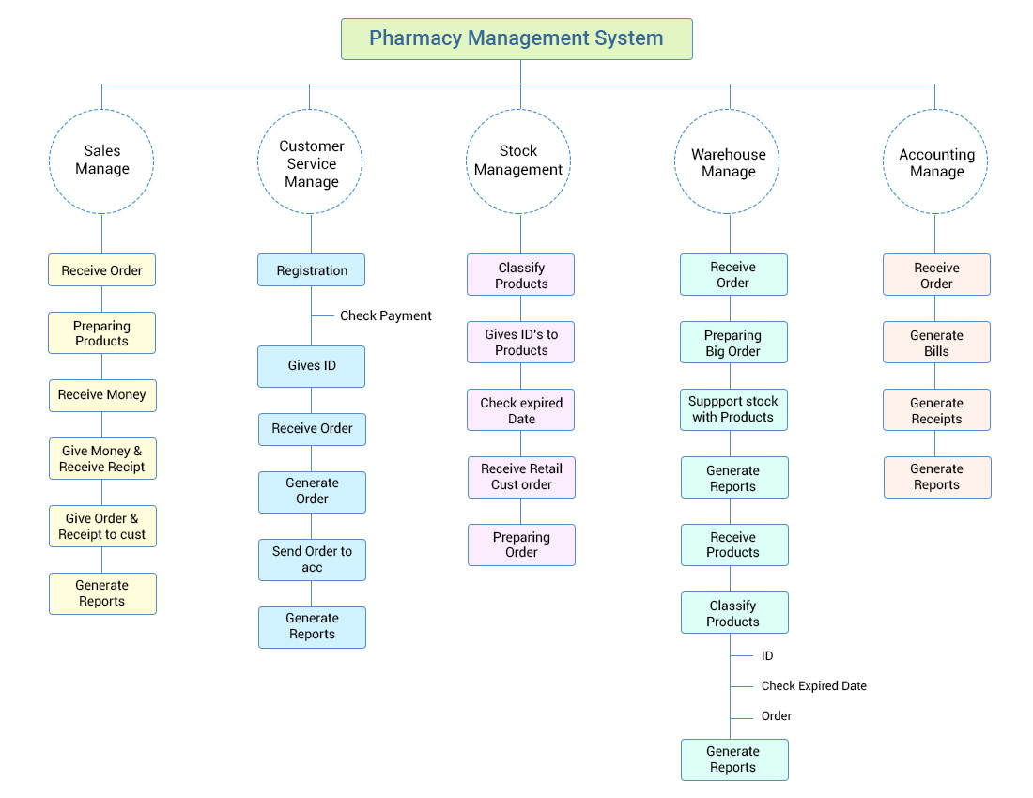

**Suppliers and stock connections**

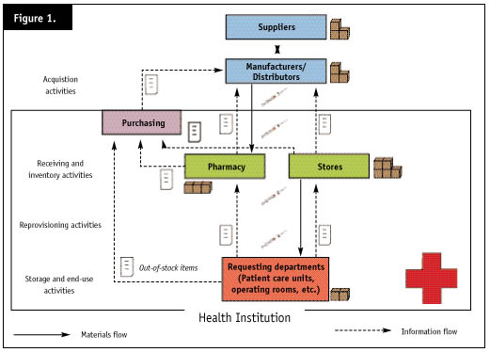

1. Use case description: Log in to the System

|  |  |
| --- | --- |
| **Use case name** | Login to System |
| **Summary** | System validates the user |
| **Actor** | Pharmacy manager |
| **Precondition** | the login page must be displayed |

**Flow of event:**

1. The pharmacy manager going to the login menu and click on it.
2. System prompts the user for username and password
3. The pharmacy manager inserts username and password to the fields.
4. System checks the username and password.
5. If the input were valid, then the system will display general system of the pharmacy system.

**Alternative sequence:**

* Step 5: If the username or password is incorrect, the system displays an error message and promptsfor the correct username and password.
* Step 5: If the user tries to insert an incorrect username and password three times without restarting the System, it will force close.
* Step 1-4: If the user clicks on cancel, the system will go to the pharmacy’s navigation page

2. Use case description for Info about pharmacy

|  |  |
| --- | --- |
| **Use case name** | Get Info About Pharmacy |
| **Summary** | Information about the pharmacy |
| **Actor** | Pharmacy manager |
| **Precondition** | Login is successful |

**Flow of event:**

1. The pharmacy manager initiates the system.
2. The system displays the first page.
3. The first page consists of menu’s medicine, and About pharmacy
4. The customer or the pharmacy manager enters Medicine menu
5. System displays the medicine available on the pharmacy with cost and purpose.
6. The customer or the pharmacy manager enters About pharmacy
7. System displays about the organization services and establishment.

**Alternative sequence**

* Step 5-7: if the user enters cancel the pharmacy management system will stop the operation.

**Time required**: The transaction must be process less than two seconds.

3. Use case description for Add New Medicine Data

|  |  |
| --- | --- |
| **Use case name** | Add New Medicine |
| **Summary** | Successfully record new medicine |
| **Actor** | Pharmacy manager |
| **Precondition** | Login is successful |

**Flow of event:**

1. The pharmacy manager login into the system.
2. Go to the system settings and menus by pressing on STOCK.
3. Insert new: NAME, SUPPLIERS BRAND, CATEGORIES, PRICE and BARCODE
4. Press on the button SAVE
5. System checks the data entered whether correct or not
6. If the data’s input were correct the system saves it into the database

**Alternative Sequence:**

* Step 7: If the input form has an error the system displays “Saving error” message
* Step 1-7: if the user enters cancel the pharmacy management system will stop the operation.

**Time required**: The transaction must be process less than two seconds.

**4.** Use case description for Update Medicine Data

|  |  |
| --- | --- |
| **Use case name** | Update Medicine Data |
| **Summary** | Successfully updated medicine data |
| **Actor** | Pharmacy manager |
| **Precondition** | Login is successful |

**Flow of event:**

1. Go to the system settings and menus by pressing on STOCK
2. Press button MODIFY
3. Insert new: NAME, SUPPLIERS BRAND, CATEGORIES, PRICE and BARCODE
4. Press on the button SAVE
5. System checks the data entered whether correct or not
6. If the data’s input were correct the system saves it into the database

#### Alternative sequence

* Step 6: If the input form has an error the system displays “Updating error” message
* Step 1-6: if the user enters cancel the pharmacy management system will stop the operation.

**Time required**: The transaction must be processed in less than two second

**5.** Use case description for Delete Medicine Data

|  |  |
| --- | --- |
| **Use case name** | Delete Medicine Data |
| **Summary** | Successfully deleted medicine data |
| **Actor** | Pharmacy manager |
| **Precondition** | Login is successful |

**Flow of event**:

1. Press button STOCK
2. Search for the desired item to be deleted
3. Press on button DELETE
4. All information related to the deleted item are removed from the database

#### Alternative sequence

* Step 3: If the system cannot successfully delete the medicine then system displays “not delete” message.
* Step 1-4: if the user enters cancel the pharmacy management system will stop the operation.

**Time required**: The transaction must be processed in less than two seconds.

**6.** Use case description for Searching Medicine Data

|  |  |
| --- | --- |
| **Use case name** | Search Medicine Data |
| **Summary** | Successfully Searched medicine data |
| **Actor** | Pharmacy manager |
| **Precondition** | Login is successful |

**Flow of event**:

1. Press button PURCHASE.
2. Press ENTER twice on the box where you write the medicine name.
3. A list of all items will be displayed.
4. Write the name of the item you’re searching for.
5. The system would display all items that start with the chosen input.
6. Press ENTER on the wanted item and all information would be displayed

#### Alternative sequence

* Step 4: If the system cannot find the chosen item then system displays “item does not exist” message
* Step 1-3: if the user enters cancel the pharmacy management system will stop the operation.

**Time required**: The transaction must be processed in less than two second

**7.** Use case description for change login password

|  |  |
| --- | --- |
| **Use case name** | Change Login Password |
| **Summary** | Change password for system successfully. |
| **Actor** | Pharmacy manager |
| **Precondition** | Login is successful |

**Flow of event**

1. Include login to the system and navigate settings,
2. Navigate settings and select change password,
3. Enter old password
4. Enter New password twice
5. Press change login password
6. If the new password is valid the system changes the password.

#### Alternative sequence

* Step 6: If the input old password is not correct then system displays

“Error in changing password” message

* Step 1-7: if the user enters cancel the pharmacy management

system will stop the operation.

**8.** Use case description to Enter an Invoice

|  |  |
| --- | --- |
| **Use case name** | Entering an invoice |
| **Summary** | Invoice is entered successfully. |
| **Actor** | Pharmacy manager |
| **Precondition** | Login is successful |

**Flow of event**

1. Enter Invoice number and choose USD or LBP
2. Choose supplier and date,
3. Enter the name, press Enter,
4. Modify quantities, expiry date and prices
5. After all items are entered verify your total with the supplier’s total
6. If the totals are equal press SAVE.

#### Alternative sequence

* Step 3: If it is a new item, create the new item (follow the steps mentioned

before).

* Step 5: if the totals are not equal, contact the accounting department.
* Step 5: If there’s an item missing, contact the suppliers.

10.2 Website:

1. Use case description for Info about pharmacy:

|  |  |
| --- | --- |
| **Use case name** | Get Info About Pharmacy |
| **Summary** | Information about the pharmacy |
| **Actor** | Website User |
| **Precondition** | Access Website |

**Flow of event:**

1. Access Website
2. Access Info Page on Website
3. Retrieve Info from Info Page

**Time required**: N/A

2.Use case description for Adding New Medicine

|  |  |
| --- | --- |
| **Use case name** | Add New Medicine |
| **Summary** | Successfully add new medicine |
| **Actor** | Website admin or pharmacy manager |
| **Precondition** | Login is successful |

**Flow of event:**

1. The website admin or pharmacy manager login.
2. Go to the CRUD menu
3. Press on button ADD
4. Insert NAME, SUPPLIERS, BRAND, CATEGORIES, PRICE, as well as availability
5. Press button SAVE
6. System checks the data entered whether correct or not.
7. If the data’s input were correct, the system saves it into the database

#### Alternative Sequence

* Step 7: If the input form has an error the system displays “Saving error” message
* Step 1-7: if the admin cancels the operation old data will not be changed

**Time required**: N/A.

**3.** Use case description for Deleting Medicine

|  |  |
| --- | --- |
| **Use case name** | Deleting Medicine from database |
| **Summary** | Successfully delete medicine from database |
| **Actor** | Website admin or pharmacy manager |
| **Precondition** | Login is successful |

**Flow of event**:

1. Press button DELETE.
2. Search for the desired item to be deleted.
3. Press button DELETE.
4. All information related to the deleted item are removed from the database.

#### Alternative Sequence

* Step 3: If the system cannot successfully delete the medicine then system displays “not deleted”.
* Step 1-4: if the cancels the operation the old database will not be changed

**Time required:** N/A

# 11.System evolution:

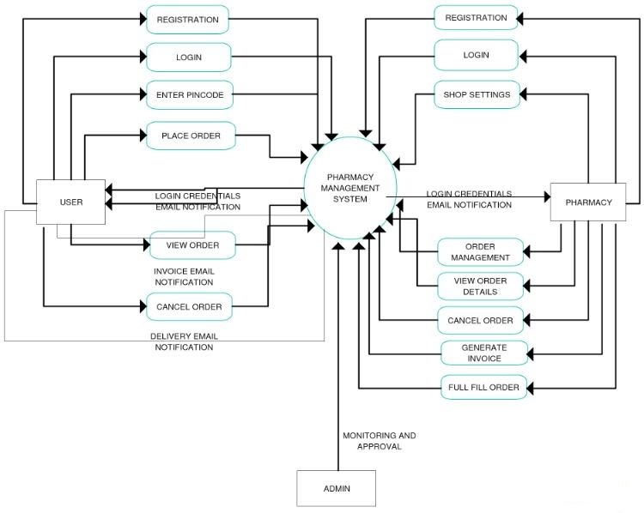

The website program is runnable and available on all platforms, it does not require any special hardware, the program needs access to internet to be available.

The pharmacy stock system requires a hardware machine of at least 32 bit and a minimum of 2 GB RAM.

**Possible changes in user needs**: (maintenance is available whenever the client faces a problem)

* The prices of items are constantly changing, an update of prices is required every 5 days.
* The website interface is updated every 6 to 10 months (if no errors were faced).

# 12.Appendices:

Hardware description:

* Pharmacy website: Any platform connected to internet.
* Pharmacy stock management system: Windows platform (the platform used in the pharmacy currently) with a minimum of 2 GB RAM and 32-bit computer.

Database description:

* Pharmacy website: phpMyAdmin or xampp is used to store and deal with the database of our website as well as connections to it.
* Pharmacy stock system: Xampp is the platform used to deal with the database, MySQL Workbench is used to store all the information in the pharmacy.

The relation between data:

Stock System:

* Every item in the pharmacy has a barcode, name, brand, category, suppliers and expiry date. The name and the barcode are used as a primary key for items. When the user is searching for an item he can search by name or by barcode. If two items have the same name the system will display both items and the user chooses the desired item.
* When deleting an item, every information connected to this item (barcode, name, brand, category, suppliers and expiry date) will be removed from the database.
* The unique key for an invoice is the invoice number. A primary key is the number of the invoice in addition to the supplier’s name. When the accounting department want to pay for the suppliers it is sufficient to search an invoice by invoice number and for a certainty the invoice number is attached to the supplier’s name.
* When modifying an item the old data is replaced by the new data entered by the user.

Pharmacy Website:

* Every item in the pharmacy has a name, brand, category, suppliers and expiry date. The names and category are used as a primary key for items. When the user is searching for an item he can search by name or by categories. If two items have the same name, the website will display both items and the user would choose the desired item.
* When deleting an item, every information connected to this item (name, brand, category, suppliers and expiry date) will be removed from the database.
* When modifying an item, the old data is replaced by the new data entered by the user.

# 13. Risk management:

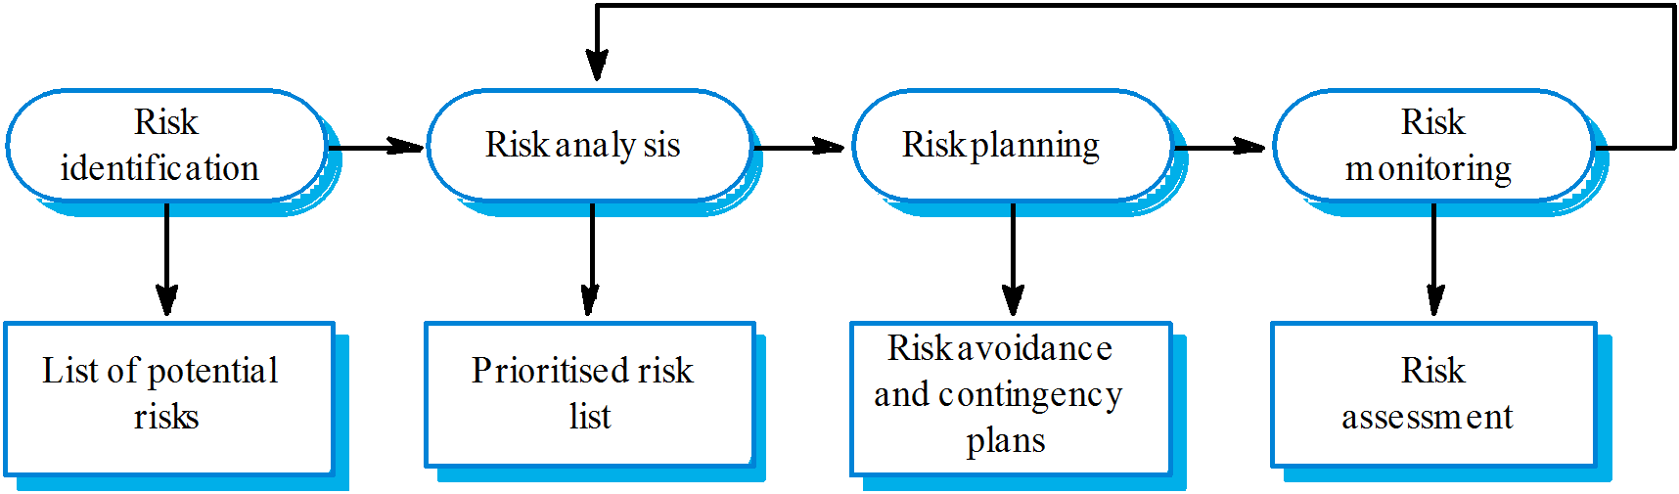

Risk identification, analysis and management:

|  |  |  |  |
| --- | --- | --- | --- |
| **Risk** | **Solution** | **Probability** | **Effects** |
| Prices change | Keep updating prices relying on OPL | High | If selling wrong prices, pharmacy can be closed. |
| Organizational financial problem | Keep track of the spending | low | Catastrophic for client and project |
| Key staff are ill at critical times | Medications and prevention | Extremely high (corona virus 😊) | Serious |
| Changes in the requirements | Following some iteration methods | Moderate | Costing time for the developers and maybe money |

# 14.Resource List:

1. **Needed software:**

Xampp, Visual Studio, Local host, Internet….

1. **Needed Hardware:**

Computer with 32 bit and 2 GB RAM.

1. **Cost Estimated:**

5 K.

# 15.Scheduling management**:**

|  |  |  |
| --- | --- | --- |
| **Item** | **Person in charge** | **Signature** |
| All stock management software related parts | Georges Younes |  |
| All website related parts (user and admin point of view) | Youssef Abboud |  |
| All activity organization parts. Proofreading and organizing the document | Christina Aouad |  |

# 16.Index:

D

database, 4, 14, 15, 16, 18, 28, 29, 31, 40, 41, 42, 46, 47, 49, 50

I

invoice, 14, 15, 16, 45, 49

**item**, 14, 16, 17, 18, 28, 33, 42, 43, 45, 47, 49, 50

items, 9, 14, 15, 16, 18, 43, 45, 49, 50

M

management, 2, 11, 14, 29, 31, 39, 40, 41, 42, 43, 44, 49, 51, 52

**Medicine**, 28, 30, 39, 40, 41, 42, 43, 46, 47

medicines, 28, 30

P

Pharmacy, 3, 17, 24, 26, 27, 28, 30, 36, 38, 39, 40, 41, 42, 43, 44, 45, 46, 49, 50

S

Stock, 3, 14, 24, 28, 31, 49

system, 4, 5, 6, 7, 8, 9, 10, 12, 14, 15, 16, 17, 18, 28, 29, 30, 31, 36, 38, 39, 40, 41, 42, 43, 44, 46, 47, 48, 49

U

Use case, 38, 39, 40, 41, 42, 43, 44, 45, 46, 47

W

website, 3, 17, 18, 19, 30, 46, 48, 49, 50, 52